ASSIGNMENT – 2
- Sum of two numbers:
num1 = int(input("Enter first number: "))
num2 = int(input("Enter second number: "))
sum = num1 + num2
print(f"Sum = {sum}")
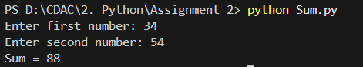
- Check Even or Odd:
num = int(input("Enter a number: "))
if num % 2 == 0:
print(f"{num} is Even")
else:
print(f"{num} is Odd")
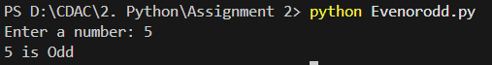
- Largest of three number
num1 = int(input("Enter first number: "))
num2 = int(input("Enter second number: "))
num3 = int(input("Enter third number: "))
if num1 >= num2 and num1 >= num3:
largest = num1
elif num2 >= num1 and num2 >= num3:
largest = num2
else:
largest = num3
print(f"Largest number is {largest}")
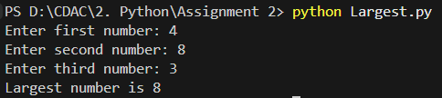
- Factorial of a Number
num = int(input("Enter number: "))
factorial = 1
for i in range(1, num + 1):
factorial *= i
print(f"Factorial = {factorial}")
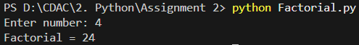
- Check prime number
num = int(input("Enter number: "))
if num > 1:
for i in range(2, num):
if num % i == 0:
print(f"{num} is not a Prime number")
break
else:
print(f"{num} is a Prime number")
else:
print(f"{num} is not a Prime number")
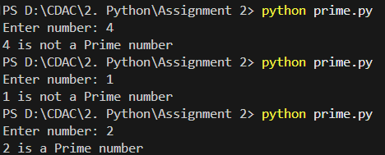
- Fibonacci Series

